# CHAPTER I: The Problem and a Review of Related Literature

**OVERVIEW**

This chapter contains the Introduction, System Project Context, Rationale of the System Project, Goals and Objectives, Scope and Constraints, and the Operational Definition of Terms. The Introduction discusses the Research Problem which focuses on safeguarding the possessions in shared workspaces. The System Project Context presents the Proposed Solution for the beneficiaries identified in the Rationale of the System Project. The Goals and Objectives highlight the necessary steps needed to complete the system with the features defined in its Scope and Constraints. Lastly, the Operational Definition of Terms gives clarification to those words used in this manuscript that may have a different meaning or use when taken in its context.

**INTRODUCTION**

In our modern day, technology really became the turning point of our society and pushed us to new heights with every discovery. According to Konsbruck Robert Lee (2015) the innovations in information technology are having wide-ranging eﬀects across numerous domains of society, and policy makers are acting on issues involving economic productivity, intellectual property rights, privacy protection, and aﬀordability of and access to information**.** One of it is the CCTVs that are made to monitor or record happenings on a certain place and global positioning systems or GPS are made to locate people, vehicle, stuffs and etc. Our world really became a place where anyone can be found no matter where they are.

The world might have already evolving continuously but there are definitely cases that can only be avoided with the use of technology like missing people and kidnappings. There are cases in which students or kids are getting lost or kidnapped out of nowhere. One of the examples is the case of the seven students killed in the Philippines while on the field trip. According to Felongco (2014), the Investigations showed that the students were having their photos taken in the area when the waters suddenly rose. This only proves that Schools are having a hard time monitoring the whereabouts of every student especially during the off campus activities like field trips or school parties held outside the campus. Kids nowadays also have a lot of habits that includes cutting classes without telling their parents that can also result in misunderstanding between the school and the parents.

The use of technology in this part is really a great help to ensure the safety of the children with the help of GPS or global positioning system in their school service vehicles. The school service will also be using a RFID for the students to tap their identification cards to indicate whether they already boarded or not and the same thing when they’re getting off and the data will be sent to the database and will send a message to the guardian or parent at the same time. This research is important to help parents to be updated of the whereabouts of their children after school. The system will be implemented only on school vehicles and not on the students.

# REVIEW OF RELATED LITERATURE AND STUDIES

The researchers used an “Arduino” program to build the system which is “Safety Monitoring System”. It has a RFID that the passenger could tap their id’s and with that the passenger’s information, the time the passenger rode in and out the vehicle and the location of the vehicle will be send via the GPS and WIFI Shield and stored the information in our database and can be viewed the records in the website. A buzzer that is used for audio signaling it is include in a system as warning that the number of passenger rode in the vehicle doesn’t match in the number of passenger rode off the vehicle or vice versa . And an emergency light, it lights up for the effectiveness of the buzzer. It has a 4x4 matrix keypad, only the owner can access the system by entering the passcode in the keypad and a serial LCD to display a human readable information if there is an intruder alert in the system. And lastly, the GSM Shield which allows the system to make phone calls and send messages to the owner whenever there is a motion detected.

**What is RFID?**

According to Christoph Jechlitschek that RFID tags, or simply "tags", are small transponders that respond to queries from a reader by wirelessly transmitting a serial number or similar identifier. They are heavily used to track items in production environments and to label items in supermarkets. They are usually thought of as an advanced barcode. However, their possible area of use is much larger. This paper presents a few new applications that are possible using RFID technology such as locating lost items, tracking moving objects, and others. RFID tags are expected to proliferate into the billions over the next few years and yet, they are simply treated the same way as barcodes without considering the impact that this advanced technology has on privacy. This paper presents possible exploits of RFID systems and some proposed solutions as well.

**File Name: rfid**

According to Ilie-Zudor, Kemeny, Egri, MONOSTORI that the RFID technology is a means of gathering data about a certain item without the need of touch- ing or seeing the data carrier, through the use of inductive coupling or electromagnetic waves. The data carrier is a microchip attached to an antenna (together called transponder or tag), the latter enabling the chip to transmit information to a reader (or transceiver) within a given range, which can forward the information to a host computer. The middleware (software for reading and writing tags) and the tag can be enhanced by data encryption for security-critical application at an extra cost, and anti-collision algorithms may be implemented for the tags if several of them are to be read simultaneously.

**File Name: RFID_MITIP2006**

According to Sridhar Iyer that it is an ADC (Automated Data Collection) technology that uses radio­frequency waves to transfer data between a reader and a movable item to identify, categorize, track. It is fast and does not require physical sight or contact between reader/scanner and the tagged item. Performs the operation using low cost components. Attempts to provide unique identification and backend integration that allows for wide range of applications.

**File Name: rfid-05**

**How does a GPS works?**

According to Principles of GPS “GPS: Global Positioning System is a worldwide radio-navigation system formed from a constellation of 24 satellites and their ground stations”

According to Wikipedia “The GPS is a Global Navigation Satellite System (GNSS) developed by the United States Department of Defence. It is the only fully functional GNSS in the world. It uses a constellation of between 24 and 32 earth orbit satellites that transmit precise radio signals, which allow GPS receivers to determine their current location, the time, and their velocity.”

According to “The GPS system consists of a network of 24 active satellites (and 8 spares) located nearly 20,000 km above the earth’s surface - that’s the same as driving from Melbourne to Perth six times! Each satellite broadcasts different signals which can be tracked by a GPS receiver on earth, which are then analysed by the GPS receiver to determine its precise location. The signals operate in all weather conditions but can’t penetrate through solid objects, so GPS receivers perform best when they have a clear view of the sky.”

**What is GSM?**

(**G**lobal **S**ystem for **M**obile Communications) A digital cellular phone technology based on TDMA that started in Europe and migrated to other continents. GSM defines the entire cellular system, not just the TDMA air interface. In the early 1990s, GSM enabled roaming across European nations for the first time, and today, more than 1.5 billion GSM customers worldwide can phone each other via roaming agreements between the carriers. AT&T and T-Mobile offer GSM service in the U.S., while Rogers Wireless uses GSM in Canada.  
Link Reference : <http://www.yourdictionary.com/gsm#ZDBevDH3OjX6Vkv3.99>

According to GPS Based Office Cab Monitoring System using RFID Technology that GSM technology is used to transmit all the information’s gathered by the module to the destined server.

**Related Studies**

According to Nurul Izzah Bt Ishak that Children Monitoring System (CMS) is a prototype device which is developed to represent how the original idea proposed which is a pair of device that are designed for children and parents where it can reduce the anxiety of the parents will lose their children while shopping at the mall. It also ensures security to prevent the disappearance of the child when in public places. This is because this product is based on the situation in which the loss occurred when the children are shopping or while in a lot of people. Technology used for this prototype is Radio Frequency (RF). According to Alina et al. (2010), radio frequency refers to alternating current (AC) which hold element such that, if the current is input to an antenna, an electromagnetic (EM) field is produce appropriate for wireless broadcasting and communications. Privileges available to product are the device that represent as children may issue loss of signal when it is reach the limitation distance which is 1.5m for this prototype project. While the device that represent as the mother or father also may emit a sound signal beep and display that “kids are missing” at the LCD when it is reach the limitation distance. Currently, parents will know where their children and continue to get their children and aware from any missing occur.

According to Abirami , Yogeshwari , Hemanjali, Nithya that a lot of children need to commute between homes to school every day. In recent days safer transportation of school children has been a critical issue as it is often observed that, the child is forgotten in the bus and also find that the bus being diverted from actual route. This project intends to find yet another solution to solve these problems by developing a bus safety system that will control the entry and exit of students from the buses through an advanced methodology. The proposed system uses RFID (Radio Frequency Identification), GPS technology to track the current position of the bus, GSM to send notification to parents regarding student and an ultrasonic sensor with buzzer to create special attention to drivers to avoid accidents.

According to K. Rajasekar, U. Kumar, G. Kumar that in this modern, fast moving and insecure world, it becomes a basic necessity to be aware of one’s safety and convenience, especially women. Nowadays every company is providing a cab to their employees. There is a real necessity in designing a system that can track the vehicle and send the information like path and location of the vehicle as well as information about the person, like location where the person gets in and gets out of the vehicle. And this system is designed towards those objectives where there are three technologies has been used to achieve the same, GPS is used to track the path and location of the vehicle, RFID has been used to identify the person as well the information like where he/she gets in and gets out of the vehicle. GSM technology is used to transmit all the information’s gathered by the module to the destined server. In addition to these a hardware setup is provisioned to perform automatic door open/close system.

According to Pallavi, Anish, Akshay, Sameera, Kokila that this paper proposes a Near Field Communication (NFC) based school kids monitoring system. Near Field Communication (NFC) is one of the latest technologies in radio communications and being a subset of RFID technology, it is growing at an enormous pace. NFC technology provides the fastest way to communicate between two devices and it happens within a fraction of a second. It has several applications in Mobile Communications and transactions. An NFC-supported school kids monitoring system is discussed as one potential use of this technology. There are many applications that are available for tracking the vehicle as the kids go to school and come back from school. The existing system gives the tracking observation of vehicle and its exact location. Even some applications give vehicle position update information to the parents. This existing system helps the parents only with the information of the vehicle but they don’t tell whether their kid is in the bus or not. To rectify these problem, we have desire to put the NFC tag into service. Each tag has a unique ID. These NFC tag are given to kids, and when students step into the school bus and touch these tag on instructor’s mobile phone, NFC readers program on instructor’s mobile phone will read these tags, identify the students from their respective NFC tag and sends a email/ message to the parents saying “Your kid is inside the bus”. Mobile phone, in turn, sends all the data it has collected to the server. The main advantage is it also displays the kid image when the card is tapped on to the phone which confirms the identity of the kid. This paper discusses NFC as a technology that is more secure and convenient than the prevalent technology of RFID.

According to Bekkali, Hamida, Kadri that millions of children need to be moved from home to school and vice versa every day. For parents, obtaining a safe transport for their children is a critical issue. Many children find themselves locked in a school bus in the bus parking lot after falling asleep on their way to school, miss the bus, step into the wrong bus, or leave at the wrong station with no method to track them. This research tested the applicability of radio frequency identification (RFID) technology in tracking and monitoring children during their trip to and from school on school busses. The child safety system developed in this research utilized the passive RFID tracking technology due to its efficient tracking capabilities, low cost, and easy maintenance. To explore the technical feasibility of the proposed system, a set of tests were performed in the lab and with the public. These experiments showed that the RFID tags were effective and stable enough to be used for successfully tracking and monitoring children using the bus. When asked to give their feedback of the solution through a questionnaire, more than 95% of the parents see that such a solution will take their anxiety and worry away and will provide them a tool to track their kids during commuting to and from their schools.

# DEFINITON OF TERMS

**RFID Tracking:** RFID tracking is based on a tag sending a radio signal to a receiver. The signal strength of the tag can be used to interpret the location of the tag. The tag and receiver combinations require an extensive network to be functional in a construction environment. Customisation of the tag-reader network is also required to use this technology (Li and Becerik-Gerber, 2011). Relying on signal strength from the tag to interpret the location of a tag is not always very accurate as radio signals are reflected due to adjacent electromagnetic surfaces such as metals, walls, etc. (Montaser and Moselhi, 2014).

**ARDUINO** - is an open-source platform used for building electronics projects consists of both a physical programmable circuit board (often referred to as a microcontroller) and a piece of software, or IDE (Integrated Development Environment) that runs on your computer, used to write and upload computer code to the physical board.

**BREADBOARD** – A breadboard is a solderless device for temporary prototype with electronics and test circuit designs

**GSM/GPRS SHIELD** – enables an Arduino board to do most of the operations you can do with a GSM phone: place and receive voice calls, send and receive SMS, and connect to the internet over a GPRS network.

**GPS Tracking:** GPS tracking is based on a GPS enabled device communicating with a network of satellites in space to determine the location of the device (Parkinson and Spilker, 1996). This type of tracking is suitable for outdoor construction projects only since a GPS enabled device indoors would not have a line-of-sight to satellites in space. It is possible to use this type of tracking in combination with other tracking technologies to locate entities on a large construction project (Andoh, 2012).

**WLAN Tracking:** A wireless device communicates with a Wi-Fi access point using radio signals. The strength of the radio signals is used to interpret the location of the wireless device in WLAN location tracking system (Behzadan et al., 2008). This technology is generally considered expensive and is suitable for indoor tracking situations. An extensive network of Wi-Fi access points is needed for utilisation in an outdoor environment. Delays in interpreting location are also noticed when numerous devices are connected to a Wi-Fi access point and the number of devices that can be connected to a Wi-Fi access point is also limited, based on the particular system selected (Shen et al., 2008).

# CHAPTER II: SYSTEM PROJECT CONTEXT

# CHAPTER II: SYSTEM PROJECT CONTEXT

# REQUIREMENTS

Figure 2. Use Case: Development of the Safety Monitoring System for School Vehicle with RFID

# MODELING

The prototype design is explained in the following diagrams. The first of which is a Use Case diagram which explains Who uses the system and What it does for each user.

Based on the diagram showed above, the system has 3 users. The first user referred in the diagram is the passenger/student, they are the one who will tap their card on the system device in which that card holds the passenger’s information, the second user referred to as the parent or guardian of the passenger, they’ll be able to log in and can view the location of the vehicle on the system website and also they’ll be able to receive an SMS through the GSM of the device informing the parent that the passenger/ student is either on aboard or off board in the vehicle. And the third user is the administrator they’re the one who manages and update the information of the system.

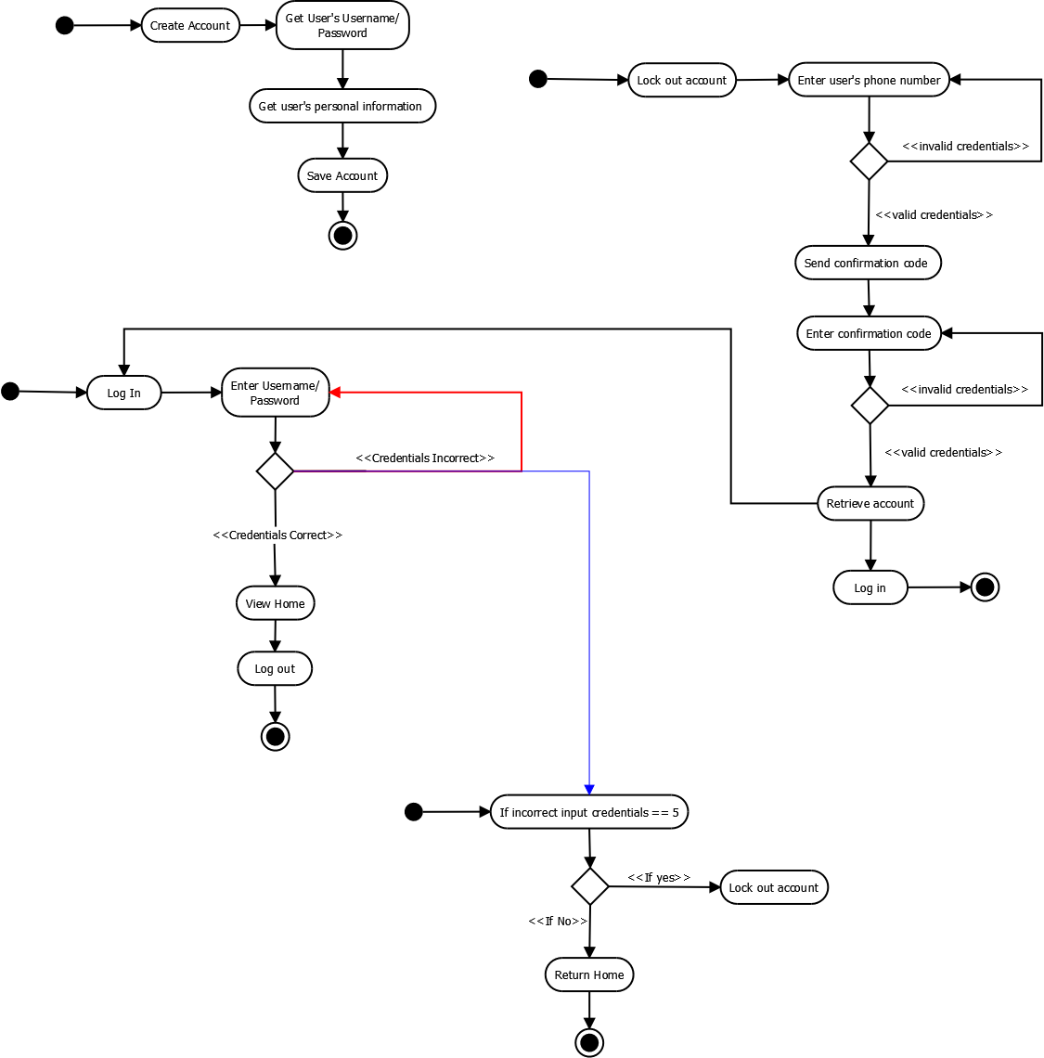Activity Diagram

|  |  |  |  |  |  |  |
| --- | --- | --- | --- | --- | --- | --- |
| **NAME**  **RELATED SYSTEM** | **DEVELOPER** | **WEBSITE** | **LATEST RELEASE** | | **FEATURE 1** | **FEATURE 2** |
| *Version* | *Date* |
| Monitoring of School Kids Using Android Devices and Near Field Communication(NFC) | Pallavi R, Anish M, Akshay I, Sameera P K, Kokila.S |  | PHP | Vol. 5, Special Issue 10, May 2016 April 26, 2014 | The current system gives the tracking report of vehicle and its exact location, driver of the vehicle as message in their smart phones. After finishing the school, parent will get the updated message from the vehicles until kid reaches home. This system helps the parents to pick up the children on time | The system has a GPS (Global Positioning System) that tracks the vehicle location and a GSM (Global System Mobile Communication) that will send an SMS to the guardian/ parent to inform them if the student/ passenger is on board or off board on the vehicle. |
| GPS Based Office Cab Monitoring System using RFID Technology | **K. RAJASEKAR1, U. THIRUMALAI KUMAR2, G. VIGNESH KUMAR3** | www.ijsetr.com |  | Vol.04,Issue.14, June-2015, | The system included two main components: a transmitting embedded module to interface in vehicle GPS and GSM devices in order determine and send automobile location and status information via SMS. | The system is also capable of transmitting a messages via GSM device and the can determine the location of the vehicle. |
| SMS Based Kids Tracking and Safety System by Using RFID and GSM | **Nitin Shyam, Narendra Kumar, Maya Shashi, Devesh Kumar** | www.ijiset.com |  | Vol. 2 Issue 5, May 2015. | The system will be designed to monitor children ridership in a safe and non-intrusive way. It will use a combination of RFID, GPS (Global Positioning System), and GPRS (General Packet Radio Service) technologies. Each student is issued one or more unique RFID card(s) to carry. | The following student/ passenger will aboard on the vehicle will be given a card that embedded with the card holder’s information to tap before and after the board on the vehicle. |
| Embedded Based School Children Safety Enhancement Using RFID | **Abirami C1, Anandha Lakshmi Yogeshwari.V2, Hemanjali. V3, C. Nithya4** |  |  | Vol. 4, Issue 3, March 2016 | The proposed system uses RFID (Radio Frequency Identification), GPS technology to track the current position of the bus, GSM to send notification to parents regarding student and an ultrasonic sensor with buzzer to create special attention to drivers to avoid accidents. | Uses also a RFID, GPS, and a GSM . |
| Smart Tracking System for School Buses Using Passive RFID Technology to Enhance Child Safety | Khaled Shaaban |  |  | Vol, 1, No. 2 December 2013 | The system will be designed to monitor children ridership in a safe and non-intrusive way. It will use a combination of RFID, GPS (Global Positioning System), and GPRS (General Packet Radio Service) technologies. As the student’s tag is detected by the reader installed in the school bus upon entering or leaving the bus, the time, date and location is logged and transmitted to a secure database. | Each student is issued one or more unique RFID card(s) to carry. After tapping it on the system device the guardian/ parents will be notified that they’re children is either on board or off board. |
| Barangay Monitoring System .NET |  | www.sourcecodester.com |  | March 27, 2010 | 1. Navigation (FirstRecord, PrevRecord etc) 2. Create, Read, Update, Delete Records  3. Generate Reports 4. Searching Capabilities 5. Flash Animation 6. Used the delegate concept | The Admin can Create, Read, Update and Delete records |
| Attendance Monitoring and Payroll System using Biometrics (Digital Persona) | [TheInstructor](http://www.sourcecodester.com/users/vincentgallardo) | www.sourcecodester.com |  | December 10, 2015 | Attendance monitoring module- Shows employee’s attendance, absences, leaves, official businesses and overtime of each employees.  Time log module, this module will record employee attendance, also this module can preview employee attendance.  Reports module, this module is where the system generates the monthly performance of the company, also reports that are generated can be printed at the same time. | Shows records of the time that the passenger enter and exit the vehicle. |
| Implementation of Student Safety System Using RFID | Aye Su Mon Kyaw, Chaw Myat Nwe, Hla Myo Tun |  |  | Volume 6, Issue 6, June 2016 | RFID-based detection unit located inside the bus detects the RFID tags worn by children. The parents can log into system website and monitor the details of their children.  The website functionality is provided by accepting request from the user’s browser and responds back HTML documents (web pages ) and files. Parents can have only access if they log in to website. | With the use of the system device together with the created website, the parents/ guardian will be able to log in and have the access to the system to view the information about the whereabouts of the vehicle and the notification if their child is on board or already off board. |
| A Decision Support Framework for Site Safety Monitoring using RFID and BIM | Anoop Sattineni |  |  | September 2014 |  |  |

**LIST OF REFERENCES**

ARDUINO - <https://learn.sparkfun.com/tutorials/what-is-an-arduino>

BREADBOARD - <http://wiring.org.co/learning/tutorials/breadboard/>

GSM/GPRS SHIELD - <https://www.arduino.cc/en/Reference/GSM>

References:

Intro: <http://gulfnews.com/news/asia/philippines/seven-students-killed-in-philippines-field-trip-tragedy-1.1374792>